Department of Computer Engineering Academic Year:2025-2026
Analysis of Algorithm -2113115 Lab Manual
SE/III

Class: BE Subject: Analysis of Algorithm Sem-III

Department of Computer Engineering Academic Year:2025-2026
Subject: Analysis of Algorithm Lab Class/Semester: SE/III
List of Experiments
Experiment No. | Aim of Experiment | Course Outcome | Bloom’s  Level
1. | Implement Insertion sort algorithm & analyze its Time & Space Complexity | LO1 | L4
2. | Implement Quick sort algorithm using Divide & Conquer approach | LO2 | L4
3. | Implement Binary search algorithm using Divide & Conquer approach. | LO2 | L4
4. | Implement Knapsack problem using Greedy Method. | LO3 | L3
5. | Implement Minimum cost spanning trees -Kruskal Algorithm. | LO3 | L3
6. | Implement Single source shortest path - Bellman Ford Algorithm. | LO4 | L3
7. | Implement Longest common subsequence algorithm using Dynamic Programming | LO4 | L3
8. | Implement N-Queens problem using Backtracking approach. | LO5 | L3
9. | Implement Sum Of Subset Problem using Backtracking approach. | LO5 | L3
10. | Implement and Compare Naive & Rabin Carp string matching algorithms | LO6 | L4

Ashvini Gaikwad Dr. Sachin Malave

Subject In-Charge

Prof. Ashvini Gaikwad AY:2025-26
Head of Department

Department of Computer Engineering

Experiment No: 1
Course Outcome: LO1 Blooms Level: L4
Aim: Implement Insertion sort algorithm & analyze its Time & Space Complexity
Abstract: This program demonstrates the use of the Insertion Sort algorithm to arrange a list of user- defined integers in ascending order. The algorithm builds the sorted list one element at a time by comparing each new element with those already sorted and inserting it in the correct position. The program takes input through a loop, stores the values in a list, and sorts them using in-place operations. This implementation highlights the algorithm’s sequential comparison and shifting approach.
Sample Input and Output:
Case 1: Best Case — Already Sorted Array Input -Enter the number of elements: 5
Enter element 1: 1
Enter element 2: 2
Enter element 3: 3
Enter element 4: 4
Enter element 5: 5
Output -
Original array: [1, 2, 3, 4, 5] Sorted array: [1, 2, 3, 4, 5]
Case 2: Average Case — Random Order Input: Enter the number of elements: 5 Enter element 1: 4
Enter element 2: 2
Enter element 3: 5
Enter element 4: 1
Enter element 5: 3
Output -
Original array: [4, 2, 5, 1, 3] Sorted array: [1, 2, 3, 4, 5]
Case 3: Worst Case — Reverse Sorted Array Input -Enter the number of elements: 5
Enter element 1: 5
Enter element 2: 4
Enter element 3: 3
Enter element 4: 2
Enter element 5: 1
Output -
Original array: [5, 4, 3, 2, 1] Sorted array: [1, 2, 3, 4, 5]

Theory:

Insertion Sort is a simple comparison-based sorting algorithm. It works much like the way we sort playing cards in our hands: we pick one card at a time and insert it into its correct position among the already sorted cards. This method is intuitive, easy to implement, and efficient for small or nearly sorted datasets. Insertion Sort builds the final sorted array one element at a time. It iterates through the list, removes one element from the input data, finds the location it belongs within the sorted portion, and inserts it there.
At each step, the algorithm maintains a sorted sub-array on the left. The current element is compared with elements in this sorted portion and inserted into its correct position by shifting larger elements one position to the right.

Pseudocode: Insertion Sort
InsertionSort(A, n)
for i ← 1 to n - 1 do key ← A[i]
j ← i - 1

while j ≥ 0 and A[j] > key do
A[j + 1] ← A[j]
j ← j - 1

A[j + 1] ← key

Insertion sort complexity
1. Time Complexity

- Best Case Complexity - It occurs when there is no sorting required, i.e. the array is already sorted. The best-case time complexity of insertion sort is O(n).
- Average Case Complexity - It occurs when the array elements are in jumbled order that is not properly ascending and not properly descending. The average case time complexity of insertion sort is O(n2).
- Worst Case Complexity - It occurs when the array elements are required to be sorted in reverse order. That means suppose you have to sort the array elements in ascending order, but its elements are in descending order. The worst-case time complexity of insertion sort is O(n2).

Program:

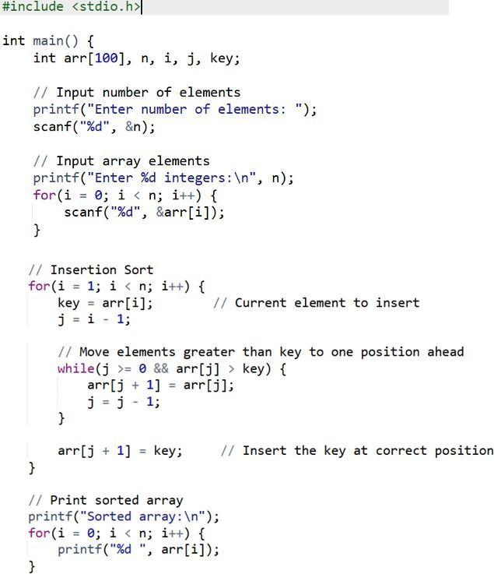

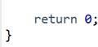

Output:

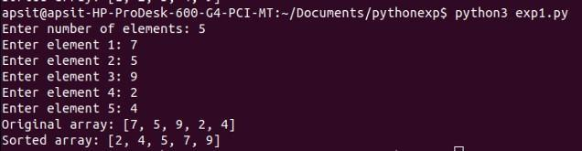
Conclusion:
Insertion Sort is a simple and easy-to-understand sorting method, It works well when the number of elements is small or the data is almost sorted. However, for large sets of data, it becomes slow compared to faster algorithms like Merge Sort or Quick Sort.
Exercise 1: Implement selection sort algorithm & analyze its Time & Space Complexity

Abstract:
This program implements the Selection Sort algorithm to sort a list of integers in ascending order. It repeatedly selects the minimum element from the unsorted portion and swaps it with the current position. The input is taken from the user, and the sorting is performed in-place using basic loop constructs.
Exercise 2:Design a program to take a list of player names and their scores and use the Bubble Sort algorithm to sort the leaderboard from the highest to lowest score. After implementation, analyze how efficient this approach is, and compare it with the performance of Insertion and Selection Sort algorithms.
Abstract:
This experiment demonstrates the use of the Bubble Sort algorithm to sort a gaming leaderboard in descending order of player scores. The program accepts names and scores as input and rearranges them using Bubble Sort logic. After implementation, the algorithm is compared with Insertion and Selection Sort in terms of time and space complexity. The experiment helps in understanding the trade-offs between different simple sorting algorithms for small datasets.

Experiment No: 2
Course Outcome: LO2 Blooms Level: L4
Aim: Implement Quick sort algorithm using Divide & Conquer approach
Abstract: The Quick Sort algorithm is an efficient, comparison-based sorting technique that follows the Divide and Conquer paradigm. In this implementation, the algorithm selects a pivot element and partitions the array such that elements less than the pivot are placed on the left and greater ones on the right. It then recursively applies the same strategy to the left and right subarrays. This process continues until the array is fully sorted. The program demonstrates how recursion and effective partitioning can result in fast and in-place sorting without the need for additional memory.
Theory:
Quicksort is a sorting algorithm based on the divide and conquer approach where an array is divided into subarrays by selecting a pivot element (element selected from the array).While dividing the array, the pivot element should be positioned in such a way that elements less than pivot are kept on the left side and elements greater than pivot are on the right side of the pivot.
The left and right subarrays are also divided using the same approach. This process continues until each subarray contains a single element. At this point, elements are already sorted. Finally, elements are combined to form a sorted array.
Pseudocode: Quick Sort
quick_sort(arr, low, high): if low < high:
pi = partition(arr, low, high) quick_sort(arr, low, pi - 1) quick_sort(arr, pi + 1, high)

partition(arr, low, high):
pivot = arr[low] # or last/mid/random
i = low + 1
j = high repeat:
while i ≤ j and arr[i] ≤ pivot: i += 1 while i ≤ j and arr[j] > pivot: j -= 1 if i ≤ j: swap arr[i], arr[j]
until i > j
swap arr[low], arr[j] return j

Time Complexity of Quick Sort

- Best Case Complexity - – It occurs when the pivot divides the array into two nearly equal halves at each recursive step. This balanced partitioning leads to a logarithmic number of levels with linear work at each level. The best-case time complexity of Quick Sort is O(n log n).
- Average Case Complexity – It occurs when the pivot divides the array into reasonably balanced parts, but not perfectly. This is typical for randomly ordered input. On average, the algorithm performs efficiently with a time complexity of O(n log n).

- Worst Case Complexity – It occurs when the pivot selection leads to highly unbalanced partitions, such as when the pivot is always the smallest or largest element (e.g., already sorted or reverse-sorted arrays). In this case, the recursion depth becomes linear, and the time complexity of Quick Sort degrades to O(n²)

Program:

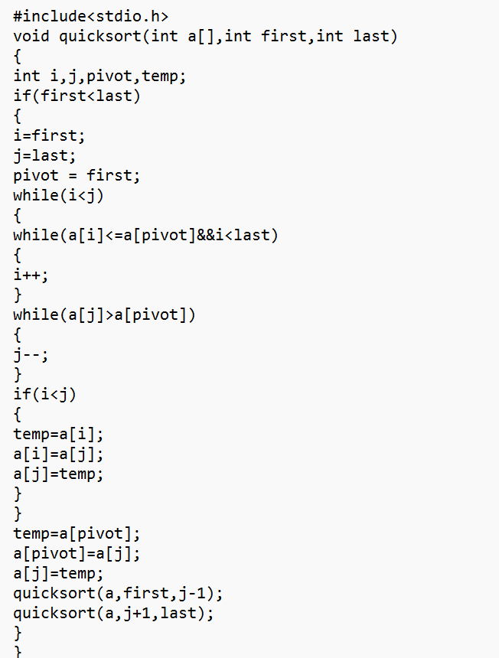

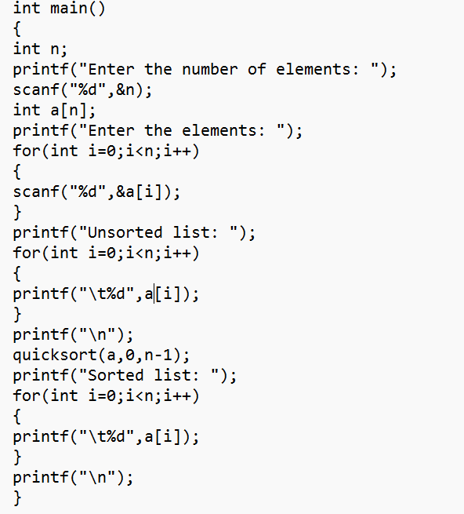

Output –

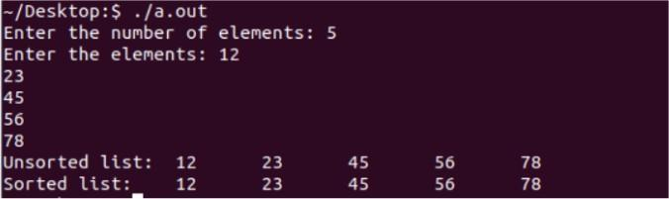

Conclusion:
Quick Sort is one of the fastest sorting algorithms in practice, especially when implemented in-place. Using the first element as pivot is simple, but can lead to worst-case time complexity on already sorted or reverse-sorted data. Still, it's widely used due to its efficiency, low memory usage, and ease of implementation.
Exercise 1: To implement the Merge Sort algorithm using the divide and conquer strategy and analyze its time and space complexity.
Abstract:
Merge Sort is a highly efficient and stable sorting algorithm that utilizes the Divide and Conquer strategy to sort elements in a list or array. The core idea involves dividing the input array into two equal halves, recursively sorting each half, and then merging the two sorted halves to produce the final sorted array. This recursive decomposition continues until subarrays of size one are reached, which are trivially sorted. In this implementation, the algorithm is structured to follow the classical recursive approach, where the merge step plays a critical role by combining two sorted arrays into one sorted result. The merge operation preserves order and ensures no element is lost or duplicated, making the sort stable.
Exercise 2: To implement a modified version of the Merge Sort algorithm that sorts an array in such a way that elements alternate between the smallest, largest, second smallest, second largest, and so on.
Abstract:
This program modifies the traditional Merge Sort algorithm to sort an array in a special alternating order: smallest, largest, second smallest, second largest, and so on. It first uses Merge Sort to sort the array in ascending order using the Divide and Conquer method. After sorting, the elements are rearranged by picking alternately from the start and end of the array using a two-pointer approach. This results in a balanced and visually intuitive pattern, useful in applications like data visualization or load distribution.

Experiment No: 3
Course Outcome: LO2 Blooms Level: L4
Aim: Implement Binary search algorithm using Divide & Conquer approach.
Abstract: Binary Search is implemented using an iterative approach to efficiently find a target element within a sorted array. The user enters a list of integers in any order, which is first sorted using Python’s built-in sorting function. The algorithm then applies the Divide and Conquer technique, continuously halving the search range by comparing the target value with the middle element. To enhance understanding, the program includes step-by-step tracing, showing the current middle index and the direction of the next search interval at each iteration.
Theory:
Binary search is a fast search algorithm with run-time complexity of (log n). This search algorithm works on the principle of divide and conquer, since it divides the array into half before searching. For this algorithm to work properly, the data collection should be in the sorted form. It looks for a particular key value by comparing the middle most item of the collection. If a match occurs, then the index of item is returned. But if the middle item has a value greater than the key value, the right sub-array of the middle item is searched. Otherwise, the left sub-array is searched. This process continues recursively until the size of a subarray reduces to zero.

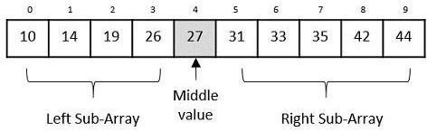
Pseudocode: Binary search Recursive
BinarySearchRecursive(arr, low, high, target): if low > high:
return -1 // Base case: target not found mid ← (low + high) // 2
if arr[mid] == target:
return mid // Target found else if arr[mid] < target:
return BinarySearchRecursive(arr, mid + 1, high, target) else:
return BinarySearchRecursive(arr, low, mid - 1, target)

Time Complexity of Binary Search
- Best Case Complexity – It occurs when the target element is found at the middle of the array in the very first comparison. In this case, only one comparison is needed. The best-case time complexity of Binary Search is O(1).
- Average Case Complexity – It occurs when the target element is found after a few recursive or iterative steps. The array is divided in half at each step, resulting in a logarithmic number of comparisons. The average-case time complexity of Binary Search is O(log n).

- Worst Case Complexity – It occurs when the element is either not present in the array or is located at the extreme end, causing the maximum number of divisions. The array continues to be halved until one element remains. The worst-case time complexity of Binary Search is O(log n).

Program:

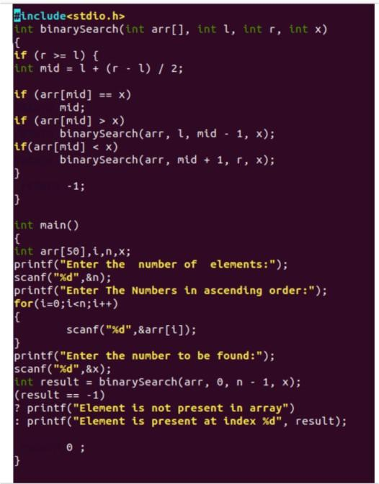

Output:

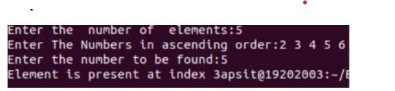

Conclusion:
Binary Search is an efficient algorithm based on the Divide and Conquer approach. By repeatedly halving
the search space, it quickly locates a target in a sorted array with logarithmic time complexity. It is widely used in applications requiring fast lookup and is fundamental to algorithmic problem-solving.
Exercise 1: Implement Min_Max algorithm using Divide & Conquer approach. Abstract:
The Min-Max algorithm can be efficiently implemented using the Divide and Conquer technique by recursively breaking the array into smaller subarrays. Each subarray is independently evaluated to find its local minimum and maximum. These local results are then merged to determine the overall minimum and maximum of the original array. this recursive division significantly reduces the total number of comparisons than brute force method.
Exercise 2: You are given a list of product IDs stored in sorted order. Develop a program that allows the user to enter a product ID to search for. The program should check whether the product ID exists in the list using Binary Search and compare its performance with Linear Search by counting the number of comparisons made in both methods. Analyze and explain the time complexity of both algorithms for searching in a sorted list.
Abstract:
The problem statement focuses on implementing and comparing Binary Search and Linear Search algorithms in Python to locate a specific product ID within a sorted list of product IDs. The user is prompted to input a sorted list and a target ID to search for. The Linear Search algorithm traverses the list sequentially, checking each element, while Binary Search uses the Divide and Conquer technique to repeatedly narrow down the search space by halving it. Both search methods are implemented with counters to track the number of comparisons made during execution. The program outputs whether the product ID was found and the number of comparisons for each method.

Experiment No: 4
Course Outcome: LO3 Blooms Level: L3
Aim: Implement Knapsack problem using Greedy Method.
Abstract: This Python implementation solves the Fractional Knapsack Problem using a greedy approach. The problem aims to maximize the total value of items that can be placed into a knapsack with a limited weight capacity. The greedy strategy involves calculating the value-to-weight ratio for each item and then selecting items with the highest ratios first, until the knapsack capacity is reached. If an item cannot fit entirely, a fraction of it is taken to fill the remaining capacity. This approach guarantees an optimal solution for the Fractional Knapsack Problem.
Sample Input and Output:
Number of items: 3 Knapsack capacity: 50

Item details (value, weight):
Item 1: value = 60, weight = 10
Item 2: value = 100, weight = 20
Item 3: value = 120, weight = 30
Output:
Selected items:
- Take 100.00% of Item 1 (value = 60, weight = 10)
- Take 100.00% of Item 2 (value = 100, weight = 20)
- Take 66.67% of Item 3 (value = 80.0, weight = 20)
Maximum value in knapsack = 60 + 100 + 80 = 240.00
Theory:
A greedy algorithm is a problem-solving strategy that makes the locally optimal choice at each step, with the hope that these local choices will lead to a globally optimal solution. Greedy algorithms do not backtrack and are usually faster than other methods like dynamic programming, but they only work when the problem exhibits two properties:
- Greedy Choice Property: A global optimum can be arrived at by selecting a local optimum.
- Optimal Substructure: The solution to a problem can be constructed from solutions to its subproblems.
Fractional Knapsack Problem –
Problem Statement:
Given:
  - A set of items, each with a weight w[i] and value v[i].
  - A knapsack with a maximum capacity W. Goal:
  - Maximize the total value in the knapsack, allowing fractions of items to be taken.
In the Fractional Knapsack Problem, we are allowed to take any fraction of an item, not just the whole item. This makes the problem perfectly suited for a greedy approach.
Greedy Strategy:
1. Compute value/weight ratio for each item.

- Sort items in decreasing order of this ratio.
- Pick items starting from the one with the highest ratio:
  - Take the whole item if it fits.
  - If not, take the fraction that fits and stop.
This approach guarantees the optimal solution due to the greedy-choice property and the problem's optimal substructure.
Pseudocode: Fractional Knapsack Algorithm
function FractionalKnapsack(capacity, items):
// Each item has value and weight for each item in items:
item.ratio = item.value / item.weight

// Step 1: Sort items by decreasing value-to-weight ratio sort(items) by item.ratio in descending order

totalValue = 0 remainingCapacity = capacity
// Step 2: Loop through sorted items for each item in items:
if item.weight <= remainingCapacity:
// Take the whole item totalValue += item.value
remainingCapacity -= item.weight else:
// Take the fractional part
fraction = remainingCapacity / item.weight totalValue += item.value * fraction
break // Knapsack is full return totalValue

Program
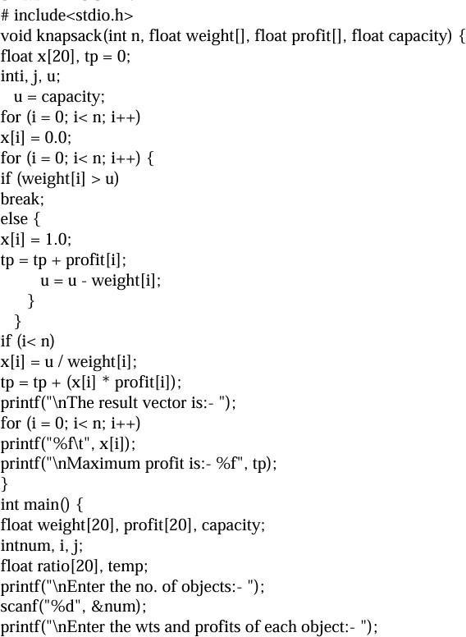

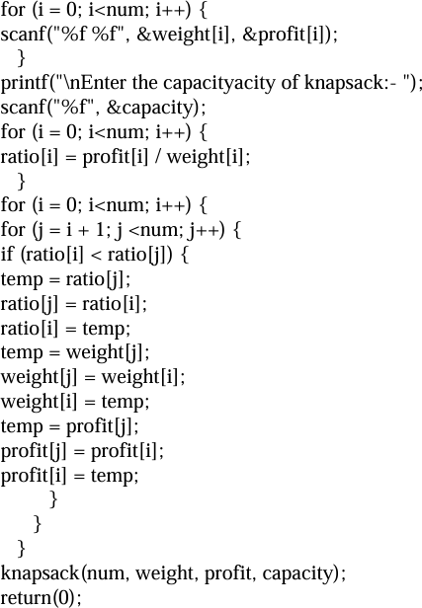
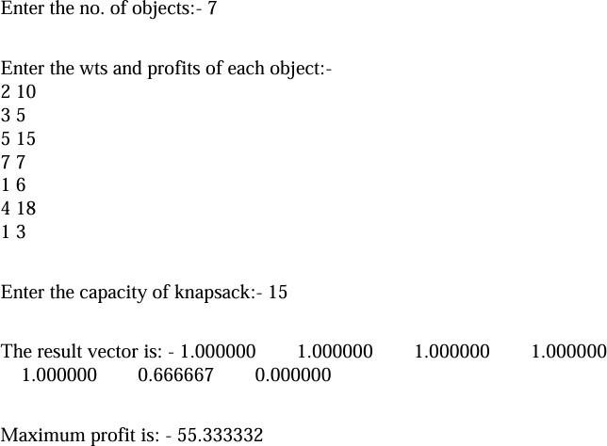

Output:

Conclusion:
The Fractional Knapsack Problem using the Greedy Method effectively maximizes the total profit within the given weight constraint, highlighting the elegance and efficiency of the greedy paradigm. It prioritizes items based on their value-to-weight ratio.
Exercise 1: Implement Job Sequencing using Greedy Method.

Abstract:
The Job Sequencing Problem aims to find a sequence of jobs, each with a deadline and a profit, such that the total profit is maximized. Each job takes one unit of time, and only one job can be performed at a time. A job must be completed by its deadline to earn its profit.
Greedy Strategy: The most common and effective greedy strategy for this problem is to:
- Sort jobs by profit in descending order.
- For each job, try to schedule it as late as possible (to keep earlier slots open for other high- profit jobs with smaller deadlines) but still within its deadline.
Exercise 2: Which algorithm can be used in a scenario where a logistics company needs to maximize the value of goods loaded into a delivery truck, without exceeding the weight limit of the truck.

Abstract:
This problem statement outlines a crucial optimization challenge for a logistics company: to determine the most valuable combination of goods to load onto a delivery truck. It requires defining a specific set of available goods, each characterized by a distinct value and weight. The primary constraint is the truck's maximum weight capacity, which absolutely cannot be exceeded. Furthermore, a critical condition is that goods are indivisible; they must be loaded entirely or not at all (i.e., no partial loading). The objective is to devise a computational approach that identifies the precise subset of goods that collectively yields the highest possible total value while strictly adhering to the truck's weight limit. This scenario necessitates the application of an algorithm suitable for discrete selection with capacity constraints, specifically aligning with the 0/1 Knapsack Problem.

Experiment No: 5
Course Outcome: LO3 Blooms Level: L3
Aim: Implement Minimum cost spanning trees -Kruskal Algorithm.
Abstract:
The Minimum Spanning Tree (MST) is a fundamental concept in graph theory with wide applications in network design, clustering, and approximation algorithms. Kruskal’s algorithm is a greedy approach that builds the MST by repeatedly selecting the smallest weight edge that does not form a cycle
Sample Input and Output:
We have a connected, undirected, weighted graph with 5 vertices: A, B, C, D, and E.
Let’s represent the graph using an adjacency matrix: A B C D E
A 0 2 0 6 0
B 2 0 3 8 5
C 0 3 0 0 7
D 6 8 0 0 9
E 0 5 7 9 0
Note:
- 0 indicates no direct edge between the nodes.
- Since it's an undirected graph, the matrix is symmetric.
Output -
Edges in MST:
A - B (2)
B - C (3)
B - E (5)
A - D (6)

Total weight of MST: 2 + 3 + 5 + 6 = 16
Theory:
A Minimum Spanning Tree (MST) is a subset of the edges of a connected, undirected, and weighted graph that connects all the vertices together, without any cycles and with the minimum possible total edge weight. A spanning tree of a graph is a tree that:
- Includes all the vertices of the graph.
- Is a subgraph (i.e., uses only existing edges of the graph).
- Has no cycles.
- Contains exactly V − 1 edges, where V is the number of vertices.
Properties of MST:
- MST has exactly V − 1 edges for V vertices.
- The MST is unique if all edge weights are distinct.
- Adding any edge to the MST will form a cycle.

- Removing any edge from the MST will disconnect the graph.
Kruskal’s Algorithm is a greedy algorithm used to find the Minimum Spanning Tree (MST) of a connected, undirected, and weighted graph. The algorithm aims to connect all vertices in the graph with the minimum total edge weight, while ensuring no cycles are formed. Kruskal’s algorithm works on the principle of greedily selecting the smallest available edge that connects two different components (i.e., does not form a cycle), until all vertices are connected.

Pseudocode: Kruskal’s Algorithm
KruskalMST(G):
Input: Graph G(V, E) with vertices V and edges E Output: Minimum Spanning Tree (MST)
Initialize MST as empty set
Sort all edges in E in non-decreasing order of their weight Create a Disjoint Set (Union-Find) for all vertices in V
for each edge (u, v) in sorted edge list:
if Find(u) ≠ Find(v): // u and v are in different sets Add edge (u, v) to MST
Union(u, v) // Merge the sets

if size of MST = V - 1: break

return MST MakeSet(v):
parent[v] = v rank[v] = 0
Find(v):
if parent[v] ≠ v:
parent[v] = Find(parent[v]) // Path compression return parent[v]

Union(u, v): rootU = Find(u) rootV = Find(v)
if rootU == rootV:
return // Already in the same set
if rank[rootU] < rank[rootV]: parent[rootU] = rootV
else if rank[rootU] > rank[rootV]: parent[rootV] = rootU
else:
parent[rootV] = rootU

rank[rootU] += 1
Time Complexity:
Sorting the edges takes O(E log E) time.
Each Union-Find operation takes near O(α(V)) time
Total time complexity: O(E log E), where E is the number of edges.

Program:

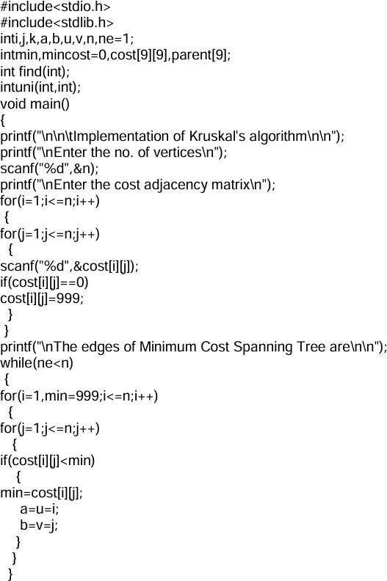

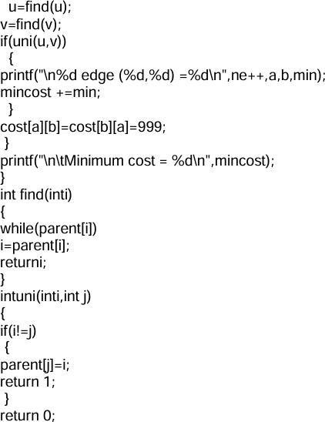
Output:
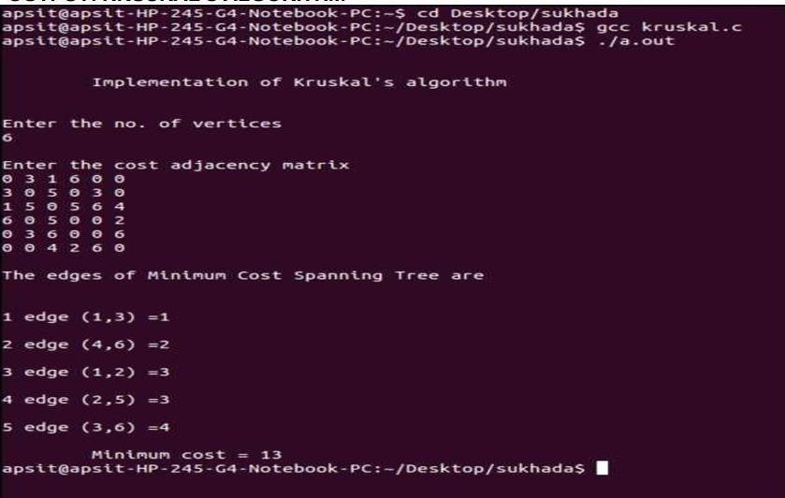

Conclusion:
Kruskal’s algorithm uses greedy approach to solve the Minimum Spanning Tree (MST) problem in a weighted, undirected, and connected graph. By sorting the edges and utilizing the Union-Find data structure, the algorithm ensures the selection of edges that result in the minimum total weight while avoiding cycles. This can be used in areas such as network design, clustering, and graph optimization.
Exercise 1: Implement Minimum cost spanning trees -Prim's Algorithm.

Abstract:
Implementation of Prim’s Algorithm to construct a Minimum Cost Spanning Tree (MST) for a connected, undirected, and weighted graph. Prim’s Algorithm is a greedy approach that builds the MST by starting from an arbitrary vertex and repeatedly adding the least expensive edge that connects a visited vertex to an unvisited vertex. The algorithm ensures that all vertices are connected with the minimum total edge weight and without forming any cycles
Exercise 2: Design a system to help users find the shortest and fastest route between two locations in a city, based on a road network. Use Dijkstra’s Algorithm to compute the minimum travel distance or time between two points.

Abstract:
Design and implement a system that assists users in finding the shortest and fastest route between two locations in a city, based on a real-world road network by using Dijkstra’s Algorithm. It is single- source shortest path problem in weighted graphs with non-negative edge weights. Represent the road network as a graph and compute the minimum travel path between any two user-specified locations

Experiment No: 6
Course Outcome: LO4 Blooms Level: L3
Aim: Implement Single source shortest path - Bellman Ford Algorithm.
Abstract:
The Bellman-Ford algorithm is a classic graph-based algorithm used for finding the shortest paths from a single source vertex to all other vertices in a weighted graph. Unlike some other shortest path algorithms, Bellman-Ford can handle graphs with negative edge weights, making it particularly useful in scenarios where such weights are common, such as in economic modeling, routing, or scheduling systems.
Sample Input and Output:
Vertices: 4 (0, 1, 2, 3) Edges:
- 0 → 1 (weight 1)
- 0 → 2 (weight 4)
- 1 → 2 (weight -3)
- 2 → 3 (weight 2)
- 3 → 1 (weight 7) INF = float('inf')
graph = [
[0, 1, 4, INF],
[INF, 0, -3, INF],
[INF, INF, 0, 2 ],
[INF, 7, INF, 0 ]
]
Output -
Shortest distances from source vertex 0: Vertex Distance from Source
0 0
1 1
2 -2
3 0
Theory:
Bellman-Ford is capable of handling graphs with negative edge weights, making it a more versatile solution in real-world applications such as routing protocols and network analysis.
The algorithm works by repeatedly relaxing all edges in the graph, gradually updating the shortest path estimates over multiple iterations. It performs V−1V - 1V−1 iterations for a graph with VVV vertices and can also detect the presence of negative-weight cycles—situations where a loop in the graph causes the total path weight to decrease indefinitely.

Pseudocode: Bellman Ford Algorithm
function BellmanFord(G, source):
// Step 1: Initialize distances for each vertex v in G:
distance[v] ← ∞
predecessor[v] ← null distance[source] ← 0
// Step 2: Relax edges repeatedly for i from 1 to |V| - 1:
for each edge (u, v) with weight w in G: if distance[u] + w < distance[v]:
distance[v] ← distance[u] + w
predecessor[v] ← u
// Step 3: Check for negative-weight cycles for each edge (u, v) with weight w in G:
if distance[u] + w < distance[v]:
print("Graph contains a negative-weight cycle") return
return distance[], predecessor[]

Time Complexity:
The time complexity of the Bellman-Ford algorithm is: O(V⋅E)
- V = Number of vertices in the graph
- E = Number of edges in the graph

Program:

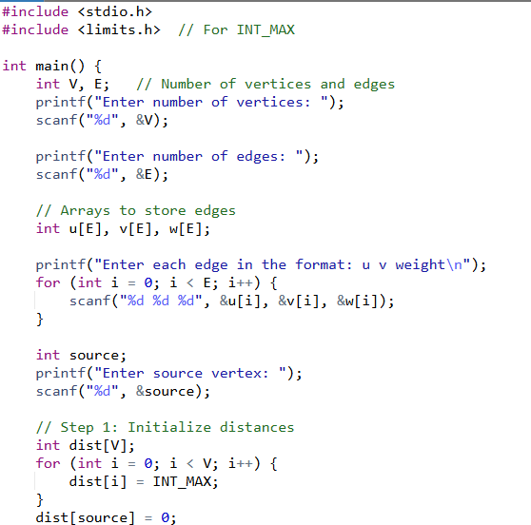

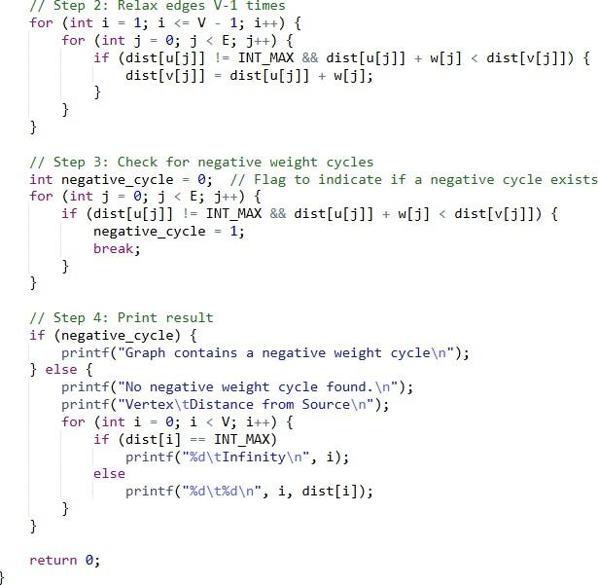

Output:

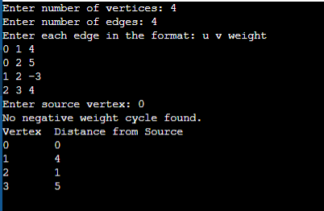

Conclusion:
The Bellman-Ford algorithm is used computing the shortest paths from a single source in weighted graphs, including those with negative edge weights. Bellman-Ford can accurately detect and handle negative-weight cycles.
Exercise 1: Dijkstra's algorithm requires that no edge weight is negative. Why is this restriction required? At what place does the algorithm fail if this restriction is removed? Can you create an example graph with one edge of negative weight where Dijkstra's algorithm fails?
Abstract:
Dijkstra’s Algorithm does not work correctly if a graph contains negative edge weights. This is because it assumes that once the shortest path to a node is found, it will not be updated later.
However, with negative edges, a shorter path may appear after a node has been processed, causing the algorithm to give incorrect results.
This failure happens during the priority queue update step, where the algorithm skips reprocessing a node even if a better (negative-weight) path is found.
For graphs with negative weights, the Bellman-Ford Algorithm is preferred, as it can correctly handle such cases.
Exercise 2: Implement a bellman ford algorithm to find shortest path from A to all other vertices: B, C, D
Edges are:

From To Weight
- B 2
- C 6
- C 3
- D 1
- D -4
Abstract:
This problem involves designing a system that computes the shortest path from a source node to all other nodes in a weighted directed graph, which may include negative edge weights. The solution uses the Bellman-Ford algorithm, a well-known dynamic programming approach that relaxes all edges multiple times to find the minimum distance. This method ensures accurate results even in graphs with negative weights (but no negative-weight cycles), making it highly effective for routing and network path calculations.

Experiment No: 7
Course Outcome: LO4 Blooms Level: L3
Aim: Implement Longest common subsequence algorithm using Dynamic Programming
Abstract:
The Longest Common Subsequence (LCS) problem is about finding the longest set of letters that appear in the same order in two different strings. We used a method called Dynamic Programming to solve this problem in an efficient way. We stored the results of smaller subproblems in a table to avoid repeating the same work. This helped us find both the length of the LCS and the actual common sequence. This method is useful in real life for comparing files, checking similarities in DNA, and finding changes between texts.
Sample Input and Output: X = "ABCBDAB"
Y = "BDCAB"
Output -
Length of LCS: 4 LCS: BCAB
Theory:
This is a good example of the technique of dynamic programming, which is the following very simple idea: start with a recursive algorithm for the problem, which may be inefficient because it calls itself repeatedly on a small number of sub problems. Simply remember the solution to each sub problem the first time you compute it, then after that look it up instead of recomputing it. The overall time bound then becomes (typically) proportional to the number of distinct sub problems rather than the larger number of recursive calls.
Pseudocode: LCS Algorithm
function LCS(X, Y):
m = length(X)
n = length(Y)
create a table L[m+1][n+1]

for i from 0 to m: for j from 0 to n:
if i == 0 or j == 0:
L[i][j] = 0
else if X[i-1] == Y[j-1]:
L[i][j] = L[i-1][j-1] + 1
else:
L[i][j] = max(L[i-1][j], L[i][j-1])
return L[m][n]
Time Complexity:
The time complexity of the LCS algorithm is: O(m*n)
- m = length of the first string
- n = length of the second string

Program:

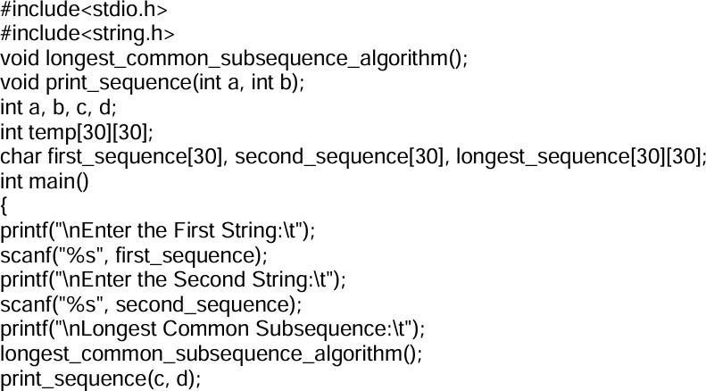

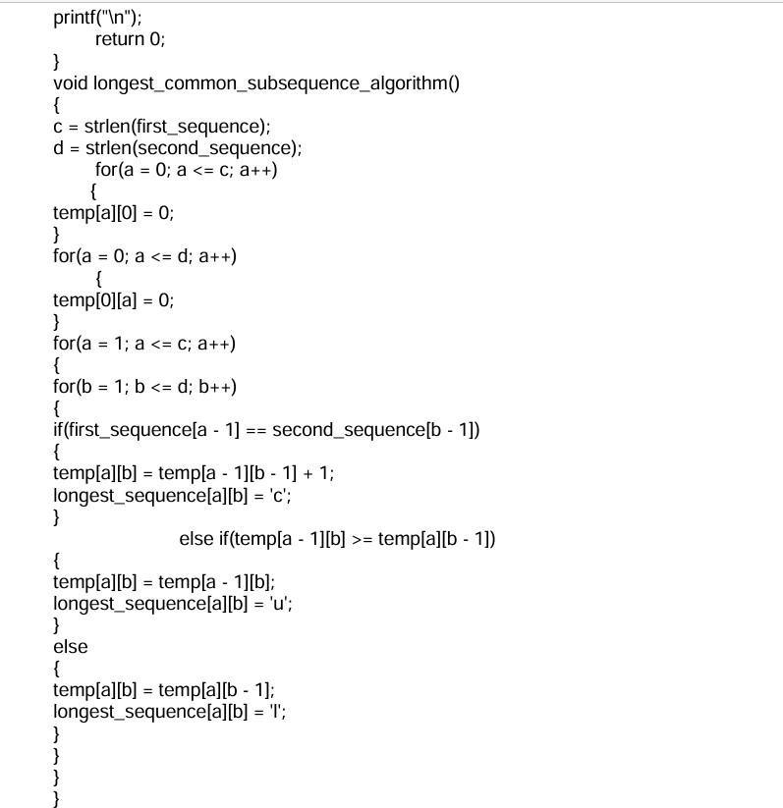

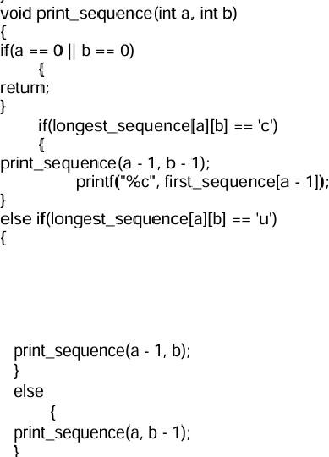
Output:

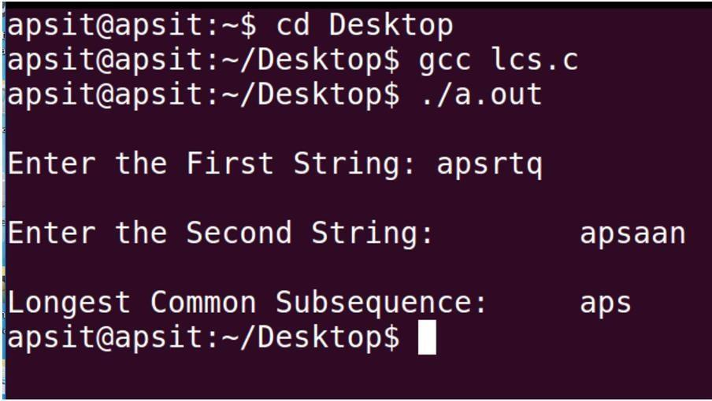

Conclusion:
The Longest Common Subsequence (LCS) is a key algorithmic technique used to find similarities between sequences. It plays a vital role in text comparison, DNA analysis, and version control by identifying the longest matching subsequence efficiently.

Exercise 1:
Implement 0/1 Knapsack algorithm using Dynamic Programming Abstract:
The 0/1 Knapsack problem is about choosing items with given weights and values to put in a bag so that the total value is maximum without going over the weight limit. Using dynamic programming, we solve this by storing answers to smaller problems and building up to the final solution. This method is faster and more efficient than checking all combinations.
Exercise 2:
Design a system to help a logistics company maximize the value of items loaded into a delivery vehicle with limited capacity. The program should consider two scenarios:

Fractional Packing Allowed → Use Greedy approach (Fractional Knapsack)
Only Full Items Allowed → Use Dynamic Programming approach (0/1 Knapsack)

Abstract:
The aim of this system is to help a logistics company choose the most valuable items to load into a vehicle with limited space. It works in two ways: if items can be divided, it uses the Greedy method (Fractional Knapsack) for fast and efficient packing; if only whole items can be packed, it uses Dynamic Programming (0/1 Knapsack) to find the best set of items. This helps the company make better use of space and increase delivery value.

Experiment No: 8
Course Outcome: LO5 Blooms Level: L3
Aim: Implement N-Queens problem using Backtracking approach.
Abstract:
The N-Queens problem is a classic puzzle that involves placing N queens on an N×N chessboard so that no two queens attack each other. The backtracking technique is used to explore all possible queen placements row by row. If a safe position is found, the algorithm proceeds; if not, it backtracks and tries a different position. This approach efficiently finds all valid solutions and demonstrates the power of recursive problem-solving.
Sample Input and Output:
Input:
n = 4
Output Solution 1:
. Q . .
. . . Q
Q . . .
. . Q .

Output Solution 2:
. . Q .
Q . . .
. . . Q
. Q . .

Input:
n = 8
Output Solution 1:
Q . . . . . . .
. . . . Q . . .
. Q
. . . . . Q . .
. . Q . . . . .
. Q .
. Q . . . . . .
. . . Q . . . .

Output Solution 2:
Q . . . . . . .
. . . . . Q . .
. Q .
. . Q . . . . .
. . . . Q . . .
. Q . . . . . .
. . . Q . . . .
. Q .

Theory:
Backtracking is a technique used to solve problems with a large search space, by systematically trying and eliminating possibilities.
- A standard example of backtracking would be going through a maze.
  - At some point in a maze, you might have two options of which direction to go:
- The backtracking strategy says to try each choice, one after the other,
  - If you ever get stuck, "backtrack" to the junction and try the next choice.
- Find an arrangement of 8 queens on a single chess board such that no two queens are attacking one another.
- In chess, queens can move all the way down any row, column or diagonal (so long as no pieces are in the way).
  - Due to the first two restrictions, it's clear that each row and column of the board will have exactly one queen.
Pseudocode: N-Queen Algorithm
Start
Function is_safe(queens, row, col):
For each previous_row from 0 to row - 1:
If queen is in the same column or same diagonal: Return False
Return True
Function print_board(queens, n, solution_number): Print solution number
For each row from 0 to n - 1:
For each column from 0 to n - 1:
If queen is placed at (row, column): Print "Q"
Else:
Print "-"
Function place_queen(row, queens, n, solution_count): If all rows are filled (row == n):
Increase solution_count Print the board
Return
For each column from 0 to n - 1:
If it's safe to place a queen at (row, column): Place the queen
Move to the next row (call place_queen with row + 1)
Function solve_n_queens(n):
Create a list "queens" to store positions of queens in each row Set solution_count = 0
Start placing queens from row 0
Main:

Ask user to enter number of queens (n) Call solve_n_queens(n)
End
Time Complexity:
O(n!)
The backtracking algorithm tries to place one queen in each row. For every row, it tries all columns (N choices).
At each step, it checks whether placing a queen is safe (i.e., no queen is in the same column or diagonal). So, in the worst case:
- Row 1: N choices
- Row 2: N-1 choices (after eliminating conflicts)
- Row 3: N-2 choices
- ...
- → This is similar to N! (factorial growth)

Program:

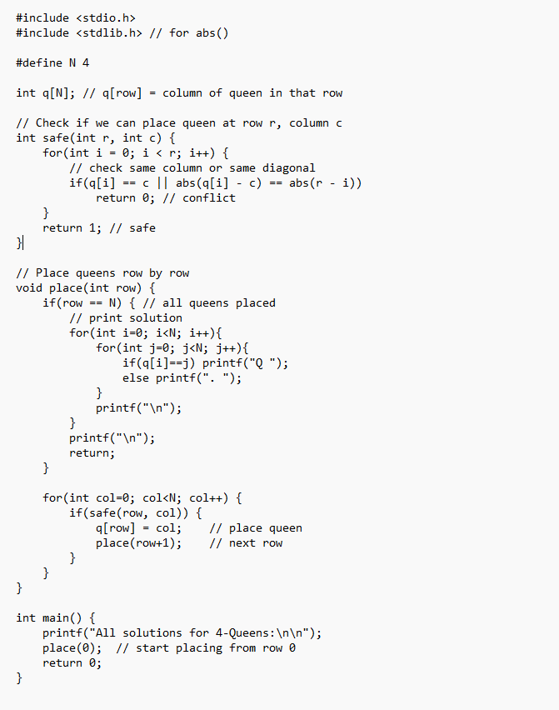

OUTPUT -

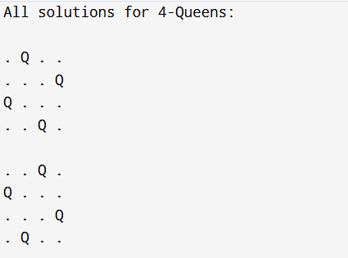

Conclusion:
The N-Queens problem can be solved using backtracking by placing queens one by one and checking for safe positions. It is an efficient way to find all valid arrangements, but the time increases quickly as N grows. This method is simple and shows how recursion and backtracking work well together.
Exercise 1:
Implement Sum of Subset problem using Backtracking approach. Abstract:
The Sum of Subset problem aims to find all combinations of numbers in a given set that add up to a specific target sum. This solution uses the backtracking method to explore possible subsets by including or excluding each element. If a subset meets the target sum, it is printed. Backtracking helps to efficiently skip unnecessary paths and reduces the number of checks needed.
Exercise 2:
How the backtracking algorithm is used to solve SODOKU puzzle illustrate step by step process and justify why it is effective ?
Abstract:
- Solving a Sudoku puzzle, which is a 9×9 grid that must be filled with numbers from 1 to 9.
- The backtracking algorithm is used to fill in the blanks (empty cells).

For each empty cell, the algorithm tries placing numbers from 1 to 9:
It checks if the number is valid — meaning it's not already present in the same row, column, or 3×3 subgrid.
If the number fits, the algorithm moves on to the next empty cell.
If it gets stuck (no number fits), it "backtracks" — it removes the last number and tries a different one. This process continues until the puzzle is solved.
Backtracking ensures that all possible options are explored, but it skips invalid paths early, making it an efficient and reliable method for solving Sudoku.

Experiment No: 10
Course Outcome: LO6 Blooms Level: L4
Aim: Implement and Compare Naive & Rabin Carp string matching algorithms
Abstract: This program demonstrates two classical string pattern matching algorithms: Naive Search and Rabin-Karp Search, implemented in a beginner-friendly way. The user inputs a main text and a pattern to search for, then selects either the Naive or Rabin-Karp method. The Naive algorithm checks every possible position in the text by comparing characters one by one. In contrast, Rabin-Karp uses a hashing technique to quickly eliminate non-matching positions, improving performance in many cases.
Theory:
Pattern matching algorithms are essential tools in computer science and data processing. These algorithms are designed to efficiently find a particular pattern within a larger set of data.

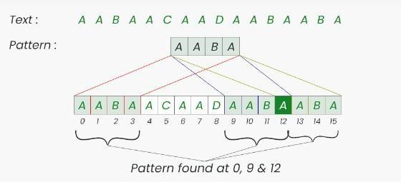

- Naive Pattern Searching Approach is one of the easy pattern-searching algorithms. All the characters of the pattern are matched to the characters of the corresponding/main string or text. In this approach, we will check all the possible placements of our input pattern with the input text.

- The Rabin-Karp Algorithm improves efficiency by using hashing. It calculates a hash of the pattern and compares it with the hash of substrings in the text. If the hashes match, it then verifies character by character to confirm the match (due to possible hash collisions).

Working Steps:

Compute hash of the pattern.

Compute hash of the first window (of size m) in the text. Slide the window from left to right:
If hash of current window matches pattern hash, verify by checking characters.Otherwise, move to the next window and update the hash using a rolling hash formula.

Time Complexity of Naive String Matching Algorithm
- Best Case Complexity
It occurs when there is a mismatch at the very first character in each window of the text. Time Complexity: O(n)

- Average Case Complexity
It occurs when the characters in the pattern and text partially match multiple times. Time Complexity: O(n × m)

- Worst Case Complexity
It occurs when the text and pattern contain many repeated characters, causing full character comparisons at each position.
Time Complexity: O(n × m)

Time Complexity of Rabin-Karp String Matching Algorithm
- Best Case Complexity
It occurs when there are no hash collisions, and all mismatches are detected quickly by comparing hash values.
Time Complexity: O(n + m)

- Average Case Complexity
It occurs when hash collisions are few, and pattern verification is needed occasionally. Time Complexity: O(n + m)

- Worst Case Complexity
It occurs when many hash collisions happen, and character-by-character comparison is done at every position.
Time Complexity: O(n × m)

Program

Output:

Rabin-Karp Program:

Output:
Conclusion:
This implementation effectively demonstrates two core string matching algorithms: Naive and Rabin- Karp. The Naive method offers clarity through simple comparisons, while Rabin-Karp introduces
hashing for improved efficiency. Together, they provide a strong foundation for understanding pattern matching, paving the way for exploring more advanced text processing techniques.
Exercise 1: Implantation of KMP String Matching Algorithm Abstract:
The Knuth-Morris-Pratt (KMP) algorithm is used to find a pattern efficiently within a given string. The
approach begins by computing the Longest Prefix Suffix (LPS) array for the pattern, which helps identify how the pattern aligns with itself. During the search, instead of rechecking characters after a mismatch, the algorithm uses the LPS array to skip ahead in the pattern, reducing redundant comparisons. The
implementation includes two main steps: generating the LPS array and performing the pattern search using this array.
Exercise 2: Design a simple Plagiarism Checker using Python. The tool should take two text inputs from the user — one original (reference) and one to check (suspect). The program will break both texts into sentences and compare them using basic string matching. If a sentence in the suspect text exactly matches a sentence in the original text, the program should report it as "copied." This helps find if any part of the suspect text is directly copied from the original.

Abstract:
In this implementation design a plagiarism detection system that uses string matching techniques to compare two documents for copied content. The system reads and processes two text inputs: a reference
document and a suspected document. It segments both texts into smaller units such as lines or sentences, and applies a string matching algorithm (e.g., KMP or Rabin-Karp) to find exact matches between them.

